AM000-Asia-China-Mirror-Warring States-W Han-Seven Arc and Cloud Mist-206 BCE-9 CE

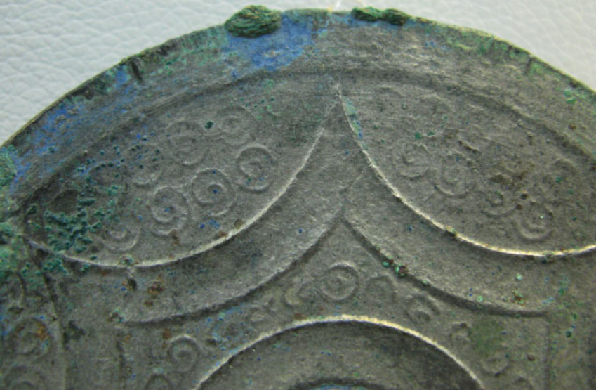

Asia-China-Mirror-Warring States-W Han-Seven Arc and Cloud Mist-206 BCE-9 CE

Cloud mist mirror, detail, showing slightly concave star-shaped arcs with spirals and granulation.

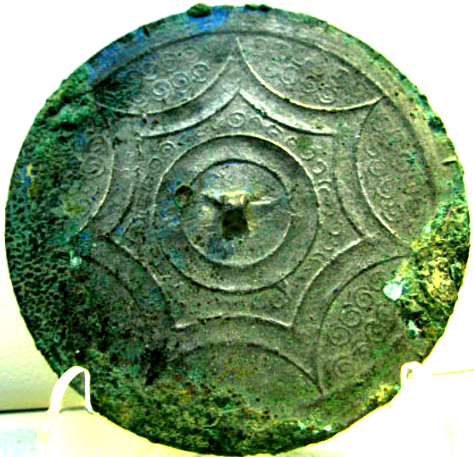

Cloud mist mirror with continuous arc design on a finely patterned ground, *ca*. 200 BCE.

The seven star-shaped arc are smooth, bare and slightly concave, against a ground of spirals and granulation, a pattern which did not survive into later Han times. Karlgren (1968:190) dates this seven pointed star or seven arc design (G10) to the 3rd Century BCE, and Nakano dates it to the Western Han dynasty (1994:98). "A new trend is obvious from the appearance of the continuous arc design, even though it is rendered in the form of a concave band used from the Warring States period onwards. The form of the seven arcs, however, is different from the geometric structure of the next period" (Nakano 1968:98).

Comparable mirrors have been excavated in the Chu region dating to the Warring States period (Li Zhenguang 1957, pls. 20 nos. 5 and 6). In Chengdu, Sichuan Province, an early Han burial site housed a seven-arc mirror of this design (Sichuan-Chingqing 1960, pl. 11). A date of 122 BCE was established for mirrors of this design from the royal burial at Nanyue (Quan 1998:308, pls 3 no 9, 4 no. 6, 5 no. 1). This style, therefore, was introduced in the Warring States period, extended through the Qin and into the early W. Han dynasty (Lei 1982: 28).

The existence of three mirrors of this design from Nanyue is provocative. Nanyue was an ancient kingdom established in 204 BCE at the final collapse of the Qin Dynasty. Zhao Tuo [趙](http://en.wiktionary.org/wiki/趙)[佗](http://en.wiktionary.org/wiki/佗) (r. 203 BCE-137 BCE), was the military commander of the Nanhai Commandery comprising conscripts from Nanhai, Guilin, and Xiang who established this kingdom. Nanyue at this time included Guangdon, Guangxi, and in 207 BCE northern Vietnam was added. His capital was in Panyu, modern Guangzhou, China. His ruling circle included both ethnic Han Chinese and native Bai Yue. This was remarkable in its day because Chinese writers depicted the Bai Yue as primitive barbarians who had tattoosand lacked the technology of archery and equestrian warfare. So when Zhao Tuo encouraged intermarriage and assimilation with the Bai Yue he was welcoming a diverse group of people into the Chinese fold (Snow 2004:270). His Vietnamese name is Triệu Đà for whom his dynasty is named in Chinese 赵朝 , and he is revered as the emperor of Vietnam. The Nanyue cloud mist mirrors would have been part of his multicultural, royal entourage. One, therefore, has to speculate about the meaning of this mirror for this diverse group of people. Perhaps by its very simplicity of design it was meant to embrace the seven realms of the Nanyue kingdom, that is, embracing all its inhabitants under heaven as symbolized by the cloud design. No other ethnic symbolism was suggested.

As a result of the growing popularity of mirrors of this design in the early Western Han Dynasty, casts of this mirror began to be mass produced. As a result of using old moulds and those made from earlier mirrors, the quality of casting deteriorated.

References:

Karlgren, Bernard. 1968. Early Chinese Mirrors, Classification Scheme Recapitulated, *BMFEA* 40: 79-98 plus 105 plates. Nakano, Toru. 1994. *Bronze Mirrors from Ancient China* ([Hong Kong]: Orientations.

Li Zhenguang. 1957. Lu tan chang sha chu tu di zhan guo shi dai tong jing, *Kaogu Tongxun* 1: 96-106.

Lei Congyun. 1982.Chu shi jing di lei xing yu fen qi, *Jianghan Kaogu* 2: 20-36.

Sichuan-Chongqing. 1960. Sichuan Provincial Museum and Chonqing city Museum. *Sichuan sheng chu tong jing*. Beijing.

Snow, Donald B. 2004.*Cantonese as written language: the growth of a written Chinese vernacular*. Hong Kong: Hong Kong University Press.